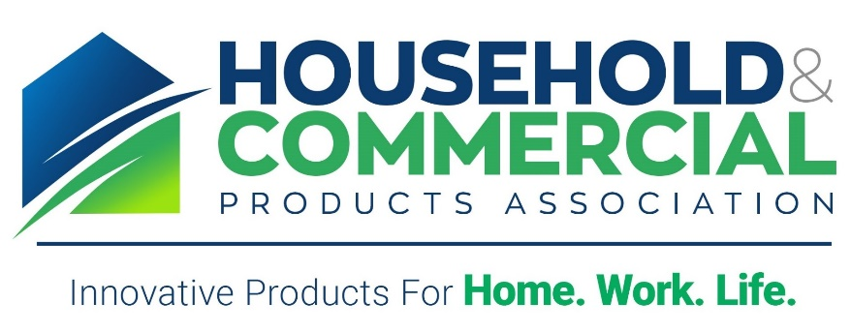

The Consumer Product Safety Commission from A to Z
Bethesda, Maryland
DRAFT AGENDA
7:45 - 8:15 am Continental Breakfast and Registration
8:15 - 8:20 am Welcoming Remarks
Julie Froelicher, The Procter & Gamble Company
8:20 - 9:00 am Keynote Speaker
Dana Baiocoo, CPSC Commissioner – (invited)
9:00 – 9:30 am Overview of the Commission
Nychelle Fleming, CPSC (invited)
- CPSC Efforts for Engagement
- CPSC Website Updates
9:30 – 10:30 am Consumer Product Safety Act
Matthew Cohen, Crowell & Morning LLP
- Section 15 Reporting
- Product Recalls
10:30 - 10:45 am Break
10:45 – 11:30 am Post Market Surveillance
Rick Kingston, SafetyCall International PLLC
- Data used by CPSC in regulatory process (NEISS DATA, TESS DATA)
- Monitoring systems used by industry
- Human Experience
11:30 – 12:30 pm Federal Hazardous Substances Act (FHSA)
Stephen Lee, CPSC
- Overview
- Labeling requirements/claims
- Enforcement
12:30 - 1:10 pm LUNCHEON - Keynote Speaker
1:20 – 2:00 pm FHSA Technical Issues
Leslie Patton, Senior Consultant, Toxicology, TSG
- Product Safety Evaluation
- FHSA Toxicity Categories (impact on signal words)
- Results of Hazard Testing/Risk Assessment
- Putting the Label Together
2:00 – 2:45 pm Poison Prevention Packaging Act
Stephanee Synnott, CPSC
- Overview
- Scope
- When is a child-resistant package required?
- Testing for child-resistance packages
- Conformity Certificates under Section 103
- Enforcement
2:45 – 3:00 pm Break
3:00 – 3:30 pm CPSC Regulatory Robot Demonstration
Shelby Mathis, CPSC
- Federal Product safety requirements
- Product safety and compliance
3:30 – 4:10 pm Non-FHSA Labeling Considerations
Michael Boucher, Crowell & Moring
- FTC Requirements (Fair Packaging and Labeling Act)
- Value of the Label
- TSCA Inventory
- Generating the correct net contents statement
- Labeling of multiple product packages, either shrink wrapped together or in a “kit”
- Other Issues (Proposition 65, VOCs, Phosphate)
4:10 – 4:50 pm Keynote Speaker
4:50 pm Wrap-Up
Julie Froelicher, The Procter & Gamble Company

